Two-Point Collinearity

Definition
# Source: AI Source: Provided by: [Data Path: Persons Table -> ID Column: 1, Name_En Column: Motasem Essam] -> From: [ChatGPT] on [7/25/2026]
Two-Point Collinearity is the simplest form of collinearity, involving two distinct points that lie on the same straight line.
For any two distinct points $A$and $B$, there is exactly one straight line passing through both points. Therefore, any two distinct points are always collinear.
$$A,B∈l$$
where $l$is the unique line determined by $A$and $B$.
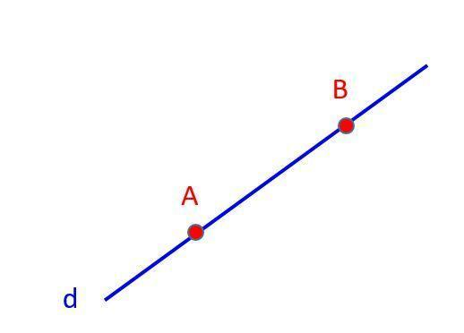
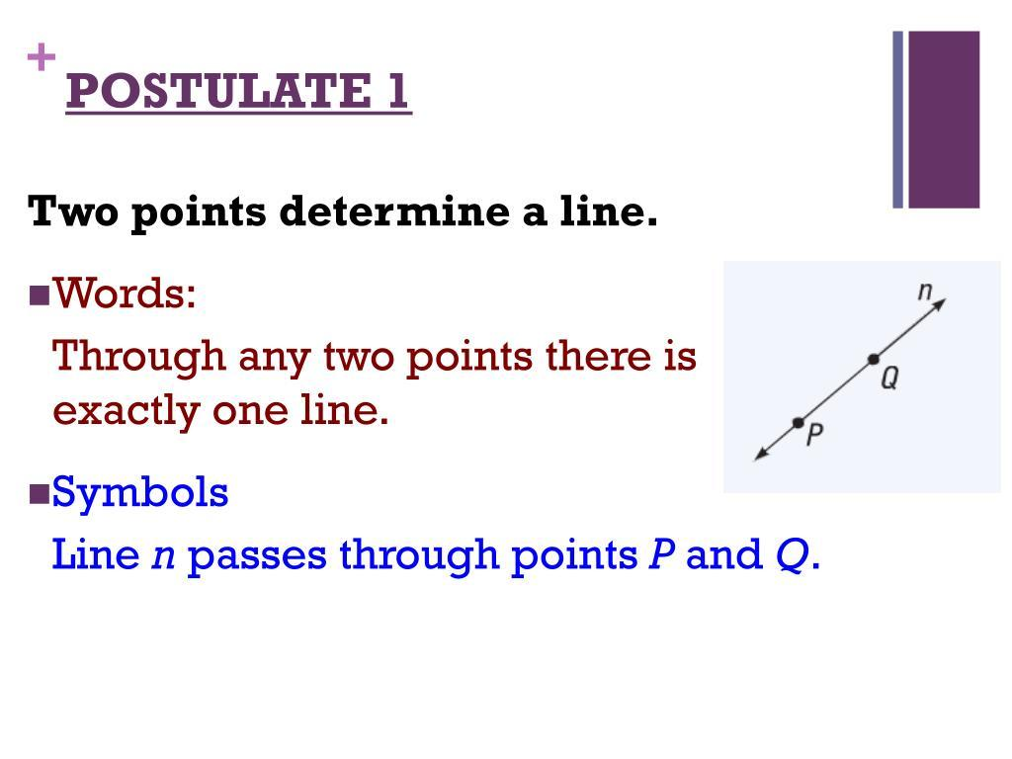
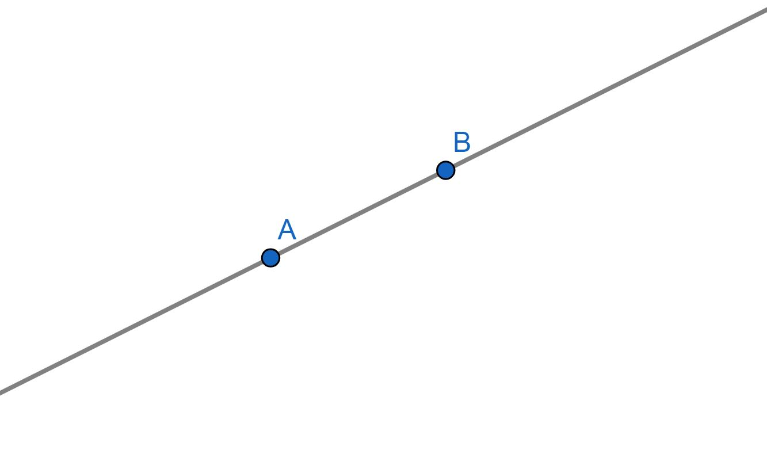

Purpose
# Source: AI Source: Provided by: [Data Path: Persons Table -> ID Column: 1, Name_En Column: Motasem Essam] -> From: [ChatGPT] on [7/25/2026]
Two-point collinearity is used to:
- Establish a straight line from two points.
- Define the unique line determined by two distinct points.
- Determine the direction of a line.
- Define line segments, rays, and lines.
- Provide the basis for testing collinearity involving three or more points.
- Construct coordinate equations of lines.

Fundamental Concept
# Source: AI Source: Provided by: [Data Path: Persons Table -> ID Column: 1, Name_En Column: Motasem Essam] -> From: [ChatGPT] on [7/25/2026]
The fundamental geometric principle is:
Through any two distinct points, exactly one straight line can be drawn.
For distinct points $A$and $B$:
$$A≠B$$
there exists exactly one line $l$such that:
$$A∈l$$
and
$$B∈l$$
Therefore:
$$\boxed{\text{Any two distinct points are collinear}}$$

Mathematical Representation
# Source: AI Source: Provided by: [Data Path: Persons Table -> ID Column: 1, Name_En Column: Motasem Essam] -> From: [ChatGPT] on [7/25/2026]
If:
$$A\left(x_{1} , y_{1}\right)$$
and
$$B\left(x_{2} , y_{2}\right)$$
are two distinct points, then the line passing through them can be represented parametrically as:
$$\vec{r}=\left(\begin{matrix}x_{1} \\ y_{1}\end{matrix}\right)+t\left(\begin{matrix}x_{2}-x_{1} \\ y_{2}-y_{1}\end{matrix}\right)$$
where $t∈R$.
The direction vector is:
$$\vec{AB}=\left(\begin{matrix}x_{2}-x_{1} \\ y_{2}-y_{1}\end{matrix}\right)$$

Slope Representation
# Source: AI Source: Provided by: [Data Path: Persons Table -> ID Column: 1, Name_En Column: Motasem Essam] -> From: [ChatGPT] on [7/25/2026]
If:
$$x_{1}≠x_{2}$$
the slope of the line determined by $A$and $B$is:
$$m=\frac{y_{2}-y_{1}}{x_{2}-x_{1}}$$
The line can then be written as:
$$y-y_{1}=m\left(x-x_{1}\right)$$
If:
$$x_{1}=x_{2}$$
the line is vertical:
$$x=x_{1}$$

Example 1 — Horizontal Line
# Source: AI Source: Provided by: [Data Path: Persons Table -> ID Column: 1, Name_En Column: Motasem Essam] -> From: [ChatGPT] on [7/25/2026]
Let:
$$A\left(2 , 4\right), B\left(7 , 4\right)$$
Both points have the same $y$-coordinate:
$$y_{A}=y_{B}=4$$
Therefore, the line through them is:
$$y=4$$
Hence:
$$\boxed{A\text{ and }B\text{ are collinear}}$$

Example 2 — Vertical Line
# Source: AI Source: Provided by: [Data Path: Persons Table -> ID Column: 1, Name_En Column: Motasem Essam] -> From: [ChatGPT] on [7/25/2026]
Let:
$$A\left(3 , 1\right), B\left(3 , 8\right)$$
Both points have the same $x$-coordinate:
$$x_{A}=x_{B}=3$$
Therefore, the line through them is:
$$x=3$$
The points are collinear.

Example 3 — General Line
# Source: AI Source: Provided by: [Data Path: Persons Table -> ID Column: 1, Name_En Column: Motasem Essam] -> From: [ChatGPT] on [7/25/2026]
Let:
$$A\left(1 , 2\right), B\left(5 , 10\right)$$
The slope is:
$$m=\frac{10-2}{5-1} \\ m=\frac{8}{4}=2$$
Therefore:
$$y-2=2\left(x-1\right)$$
or:
$$\boxed{y=2x}$$
The two points determine this unique line.

Two-Point Collinearity and Line Segments
# Source: AI Source: Provided by: [Data Path: Persons Table -> ID Column: 1, Name_En Column: Motasem Essam] -> From: [ChatGPT] on [7/25/2026]
Two distinct points also determine a unique line segment:
$$\overset{‾}{AB}$$
The segment contains all points between $A$and $B$.
A ●────────────────● B
AB
The corresponding geometric objects are:
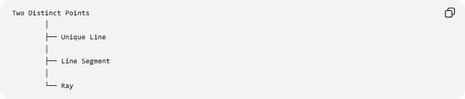
Two Distinct Points
│
├── Unique Line
│
├── Line Segment
│
└── Ray
Two points $A$and $B$can therefore define:
- the line $\overset{↔}{AB}$
- the segment $\overset{‾}{AB}$
- the ray $\vec{AB}$
- the ray $\vec{BA}$

Important Special Case: Coincident Points
# Source: AI Source: Provided by: [Data Path: Persons Table -> ID Column: 1, Name_En Column: Motasem Essam] -> From: [ChatGPT] on [7/25/2026]
Two distinct points always determine a unique line.
However, if:
$$A=B$$
then there is only one geometric point, not two distinct points.
A single point does not determine a unique line because infinitely many lines can pass through that point.
Therefore:
$$\boxed{A≠B}$$
is an important condition when stating the two-point line-determination theorem.

Two-Point vs. Three-Point Collinearity
# Source: AI Source: Provided by: [Data Path: Persons Table -> ID Column: 1, Name_En Column: Motasem Essam] -> From: [ChatGPT] on [7/25/2026]
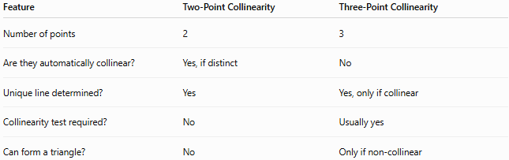
Feature | Two-Point Collinearity | Three-Point Collinearity
Number of points | 2 | 3
Are they automatically collinear? | Yes, if distinct | No
Unique line determined? | Yes | Yes, only if collinear
Collinearity test required? | No | Usually yes
Can form a triangle? | No | Only if non-collinear
The important difference is that two distinct points do not need a collinearity test.
For three points, their alignment must be established.

Key Properties
# Source: AI Source: Provided by: [Data Path: Persons Table -> ID Column: 1, Name_En Column: Motasem Essam] -> From: [ChatGPT] on [7/25/2026]
- Any two distinct points are collinear.
- Exactly one straight line passes through two distinct points.
- Two points determine a unique line.
- Two points determine a unique line segment.
- Two points can determine two opposite rays.
- No slope calculation is needed to establish two-point collinearity.
- If the two points coincide, they do not determine a unique line.
- Two points alone cannot form a non-degenerate triangle.

Conclusion
# Source: AI Source: Provided by: [Data Path: Persons Table -> ID Column: 1, Name_En Column: Motasem Essam] -> From: [ChatGPT] on [7/25/2026]
Two-Point Collinearity is the fundamental case of collinearity. Any two distinct points necessarily lie on one unique straight line, making them automatically collinear. This principle is the foundation for defining lines, line segments, rays, and for studying collinearity involving three or more points.

